**DAILY ONLINE ACTIVITIES SUMMARY**

|  |  |  |  |  |  |  |  |  |
| --- | --- | --- | --- | --- | --- | --- | --- | --- |
| **Date:** | **21/05/2020** | | | | | **Name:** | **Anusha** | |
| **Sem & Sec** | **8th A** | | | | | **USN:** | **4AL16CS014** | |
| **Online Test Summary** | | | | | | | | |
| **Subject** | | **SMS** | | | | | | |
| **Max. Marks** | | **60** | | **Score** | | | **60** | |
| **Certification Course Summary** | | | | | | | | |
| **Course** | Introduction to Hadoop | | | | | | | |
| **Certificate Provider** | | | **Great learning** | | **Duration** | | | **15 mins** |
| **Coding Challenges** | | | | | | | | |
| **Problem Statement:** | | | | | | | | |
| **Status: COMPLETED** | | | | | | | | |
| **Uploaded the report in Github** | | | | | **YES** | | | |
| **If yes Repository name** | | | | | **anushasuvarna-014** | | | |
| **Uploaded the report in slack** | | | | | **YES** | | | |

Online Test Details:

Test on module 3

Snapshot of test



Certification Course Details:

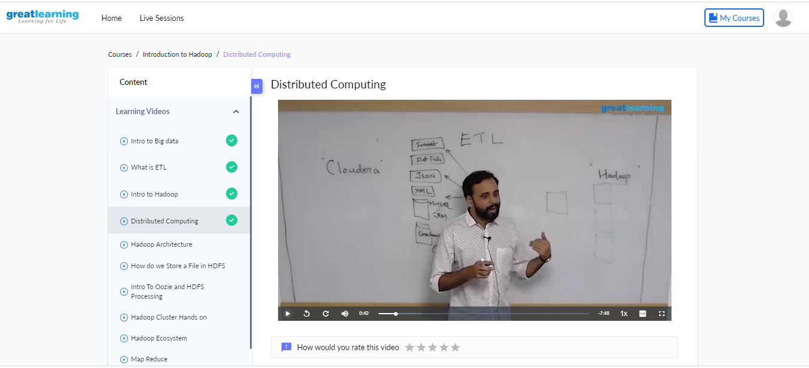

In Hadoop Distributed File System there are two nodes namenode and datanode. Here namenode acts like a master and datanode acts like a slave we can have any number of slaves. In HDFS we can delete any file but small editing is little difficult but is possible by using other platform.HDFS takes care of storage.

Coding Challenges Details

Create SLL, and then reverse the link in SLL until head becomes NULL. Each time reversing the link head must be moved to next immediate node.

|  |
| --- |
|  |
|  |
|  |  |
|  |  |
|  | **Solution:** |
|  |  |
|  | **#include <stdio.h>** |
|  | **#include <stdlib.h>** |
|  | **struct node** |
|  | **{** |
|  | **int data;** |
|  | **struct node *next;** |
|  | **};** |
|  | **struct Node reverse(struct Node head,int k)** |
|  | **{** |
|  | **struct Node current= head;** |
|  | **struct Node next= Null;** |
|  | **struct Node prev= Null;** |
|  | **int count = 0;** |
|  | **while(current!=Null && count<k)** |
|  | **{** |
|  | **next= current->next;** |
|  | **current->next = prev;** |
|  | **prev= current;** |
|  | **current= next;** |
|  | **count++;** |
|  | **}** |
|  | **if ( next!=Null)** |
|  | **head->next= reverse( next,k);** |
|  | **return prev;** |
|  | **}** |
|  | **void push( struct Node ==head_ref,int new_data)** |
|  | **{** |
|  | **struct Node= new_node= (struct Node*) malloc(sizeof(struct Node));** |
|  | **}** |
|  | **}** |
|  | **int main()** |
|  | **{** |
|  | **Struct node *prev,*head,*p;** |
|  | **int n,i;** |
|  | **printf ("number of elements:");** |
|  | **scanf("%d",&n);** |
|  | **head=NULL;** |
|  | **for(i=0;i<n;i++)** |
|  | **{** |
|  | **p=malloc(sizeof(struct node));** |
|  | **scanf("%d",&p->data);** |
|  | **p->next=NULL;** |
|  | **if(head==NULL)** |
|  | **head=p;** |
|  | **else** |
|  | **prev->next=p;** |
|  | **prev=p;** |
|  | **}** |
|  | **return 0;** |